**First Progress Report**

on

**Dynamic routing**

Submitted in partial fulfillment of the requirements for the award of degree of

**BACHELOR OF ENGINEERING**

**IN**

**COMPUTER SCIENCE & ENGINEERING**



**Submitted By: Project mentor: Er. Inderjeet singh**

**Simranjeet singh**

**17bcs1708 Signature of project mentor**

**DEPARTMENT OF COMPUTER SCIENCE & ENGINEERING**

**CHANDIGARH UNIVERSITY, GHARUAN**

**Globalization: Interconnected worlds**

## Existing System

## Since the actual processing of the data takes place on the remote client the data has to be transported over the network, which requires a secured format of the transfer method.  The transfer the large amount of data through the network will give errors while transferring. Nevertheless, sensitive data transfer is to be carried out even if there is lack of an alternative.

## As the global network is very huge sometime it is very difficult to connect with different countries with their clients. We can communicate with different clients at any time and sends the messages.

## Network security in the existing system is the motivation factor for a new system with higher-level security standards for the information exchange.

## Proposed System

This system is a bunch of benefits from various points of views. As this network connected with different countries network, day to day communication can be done faster and precisely.

There is a main server which stored the address of the other server which comes under the main server. Different countries have their own router, switches and the server which have the main link with the main server. There are different routers which are connected through the switches and the different clients are connected with it and the different ip address is allocated for the security.

It should also identify the user and provide the communication according to the prescribed level of security with transfer of the file requested and run the required process at the server if necessary. In this system the data will be sending through the network as an audio file. The user who received the file will do the operations like de embedding, decryption, and decompress in their level of hierarchy etc.

**Security:** Network security is the security provided to a network from unauthorized access and risks. It is the duty of network administrators to adopt preventive measures to protect their networks from potential security threats.

Computer networks that are involved in regular transactions and communication within the government, individuals, or business require security. The most common and simple way of protecting a network resource is by assigning it a unique name and a corresponding password.

Security management for networks is different for all kinds of situations. A home or small office may only require basic security while large businesses may require high-maintenance and advanced software and hardware to prevent malicious attacks from hacking and spamming. In order to minimize susceptibility to malicious attacks from external threats to the network, corporations often employ tools which carry out network security verifications.

**Access-list:** Access Control List (ACL) are filters that enable you to control which routing updates or packets are permitted or denied in or out of a network. They are specifically used by network administrators to filter traffic and to provide extra security for the network. This can be applied to routers (Cisco).ACLs provide a powerful way to control traffic into and out of your network; this control can be as simple as permitting or denying network hosts or addresses.  You can configure ACLs for all routed network protocols. The most important reason to configure ACLs is to provide security for your network. However, ACLs can also be configured to control network traffic based on the TCP port being used.

**NAT (Network Address Translation):** Network address translation (NAT) is a method of remapping one IP address space into another by modifying network address information in the IP header of packets while they are in transit across a traffic routing device. The technique was originally used as a shortcut to avoid the need to readdress every host when a network was moved. It has become a popular and essential tool in conserving global address space in the face of IPv4 address exhaustion. One Internet-routable IP address of a NAT gateway can be used for an entire private network.

* Switches: A network switch is a computer networking device that connects devices on a computer network by using packet switching to receive, process, and forward data to the destination device.
* Routers: A router is a networking device that forwards data packets between computer networks. Routers perform the traffic directing functions on the Internet.
* Servers: In computing, a server is a computer program or a device that provides functionality for other programs or devices, called "clients". This architecture is called the client–server model, and a single overall computation is distributed across multiple processes or devices.
* Cables: An electrical cable is an assembly of one or more wires running side by side or bundled, which is used to carry electric current. A cable assembly is the composition of one or more electrical cables and their corresponding connectors.
* DNS: The Domain Name System (DNS) is the phonebook of the Internet. Humans access information online through domain names, like nytimes.com or espn.com. Web browsers interact through Internet Protocol (IP) addresses. DNS translates domain names to IP addresses so browsers can load Internet resources.
* DHCP: The Dynamic Host Configuration Protocol is a network management protocol used on UDP/IP networks whereby a DHCP server dynamically assigns an IP address and other network configuration parameters to each device on a network so they can communicate with other IP networks.
* SMTP: SMTP (Simple Mail Transfer Protocol) is the protocol used in sending (outgoing) emails. SMTP is the protocol always used for sending (outgoing) emails.

**Progress/Implementation:**

In this project I have made connection using different topologies like bus, tree and star. Different topology is used to design network in every different countries. I have also included a telephone in every different countries to connect with other for emergency.

All telephones are connected to each other and each telephone has specific number which can be used to call each other. Topologies are connected using Static Routing, Rip Routing and EIGRP Routing .IP Addressing is done by dhcp pool method in which IP address is given to a pc automatically.

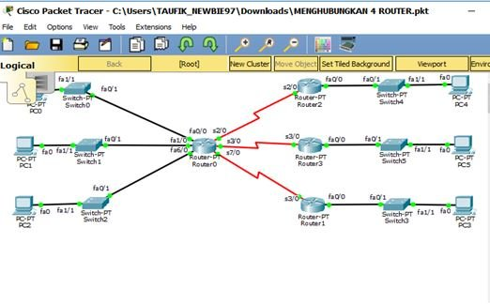

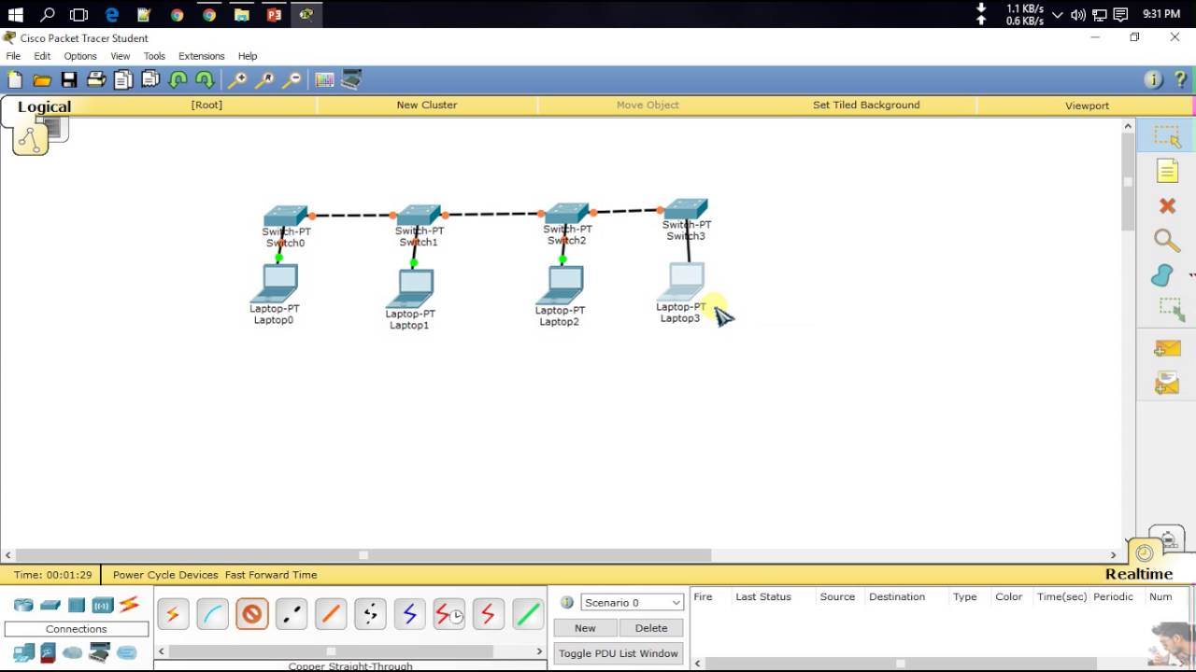

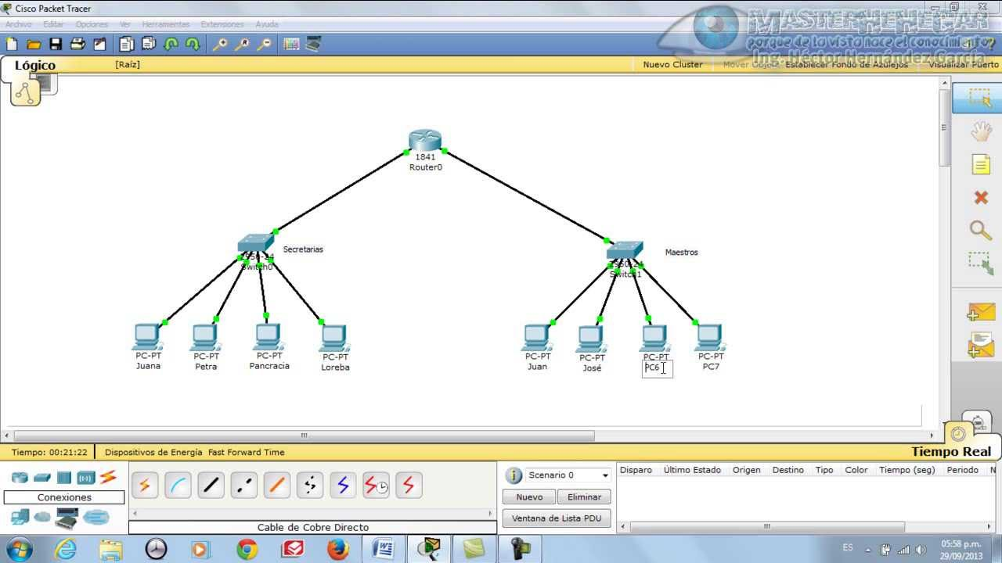

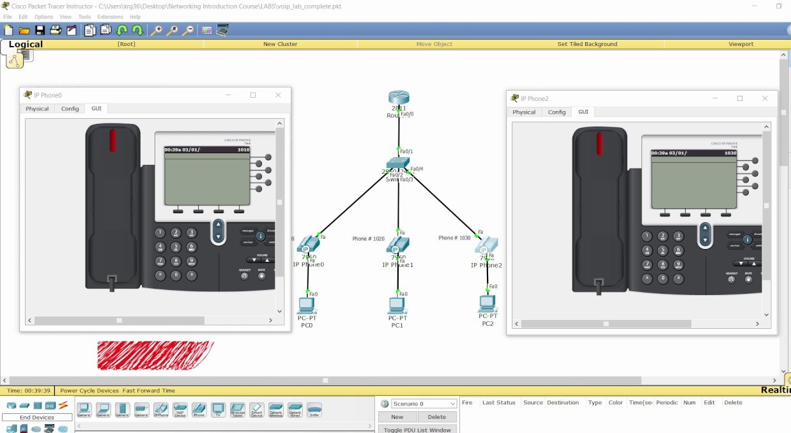

**Software requirement:**

* Cisco Packet Tracers: Version 6.0.1
* Operating system: windows and Linux

**Hardware requirement:**

* CPU: Intel Pentium 4, 3.0 GHz or better.
* RAM: 4 GB or more.
* Storage: 1.6 GB of free disk space.